PUBLIC RELATIONS CELL

PRESS RELEASE

MUMBAI PORT JUMPS TWO NOTCHES UP TO THE 4TH RANK

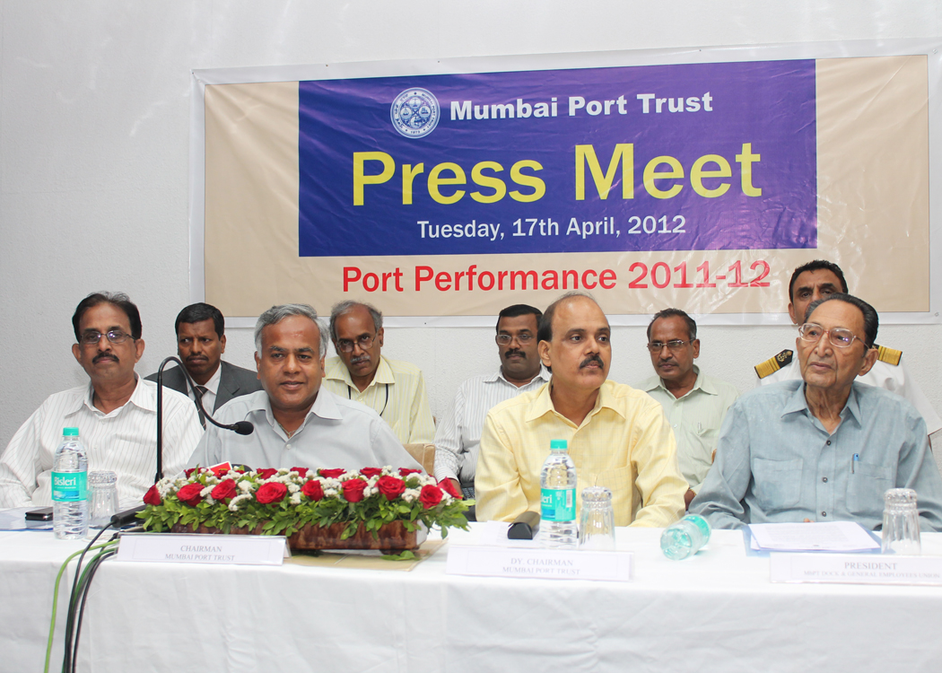

The Mumbai Port Trust has raced to 4th position in all India ranking overtaking two Major Ports clocking 56.19 million tonnes in 2011-12, a rise of 3% over the previous year's traffic of 54.59 million tonnes. Against the negative growth of 1.73% of all Major Ports, the MbPT performance stands out. The rise was due to theresurgent performance especially in last quarter with last month March 2012 at all time high traffic of 5.96 million tonnes.

2. Most major commodities have shown improvement, except in
containers & POL. Till year 2009 POL cargo handled ex-ONGC pipelines
through MbPT was included in the throughput. Considering 3.03 million
tonnes of this ONGC cargo, then MbPT traffic is an all time record of 59.22
million tonnes.

3. MbPT also owns and operates a wide railway network and carries out freight movement. In 2011-12 an all time record traffic of 36.40 lakh tonnes were handled by the Port Railway system as against 27.70 lakh tonnes in 2010-11, a rise of 31.41%. Notably, 8.49 lakh tonnes of domestic cement was handled, eliminating entry of so many (about Eighty Thousand) truck movements into city which reduced traffic congestion and pollution.

4. On productivity parameters there is improvement of 3%. The ship day output increased in 2011-12 to 7709 tonnes from 7487 tonnes in 2010-11. The Port is getting larger parcel size ships with average parcel size of 19773 tonnes against 18221 i.e. rise of 8.52% with number of ships using Port services increasing to 5761 nos. against 5622.
5. Unlike many single commodity Ports, Mumbai Port caters to entire
range of cargo types like break bulk, project cargo, edible cargo, POL,
coal, chemicals, automobile, cement, fertilizers. This requires highly versatile manpower & facilities as the variety in cargo types and ever-changing packaging poses a challenge to achieving efficient, cost effective & safe handling. The Port enjoys the status of the most preferred Port for handling project cargo. Over-dimensional packages, infrastructure equipment, higher capacity cranes in transit and other heavy machineries are regularly moving through the Port. The Mumbai Port continues to be the number one cruise port of India with around 60 international cruise calls.

6. Pro-active policies of the Port led to reduced cost of handling
in Mumbai Port. Some measures taken are:

- Extension of pre-shipment storage facilities for Iron & Steel and
vehicles.
- Concessional storage facility for import bagged cargoes.
- Concessional demurrage on export of agri products.
- More free days for fertilizers/fertilizer raw materials handled at Hay Bunder.
- Increase in free days for cargo and containers.
- Reduction in stevedoring charges for midstream discharging/ topping up operations.
- Concessional rate to coastal cargoes at 60%.

7. Some of the notable achievements in handling cargo during the year
are:

- Highest parcel size of pulses (58254 MT) was handled ex-M.V. Friendly Seas in October 2011.
- Highest ship day output of 53461 MT on 9.4.2011.
- One of the largest cruise vessel M.V. Costa Deliziosa with GRT of 93,000 MT berthed at BPX on 17.3.2012.
- A large parcel size of 2361 vehicles loaded on car carrier M.V. Grand Sapphire on 20.12.2011.
- M.V. Peace Angel with one of the largest parcel size of imported steel (55014 MT) called.
- Two brand new ships viz. M.V.Rickmers Yokohama and M.V.Rickmers, Tianjin made maiden calls on 6.9.2011 and 4.1.2012 respectively.
8. The target for next year is 61 million tonnes. The thrust will be
to improve POL and container traffic. To woo POL cargo, Port Management has already offered priority berthing to ONGC vessels, which would increase
utilization of Port’s Jawahar Dweep facility and contribute to growth of
traffic. As a consequence in the first 15 days of April 2012, ONGC Crude handled is 2.90 lakh tonnes. This is a sharp increase against the monthly average of 2.25 lakh tonnes in the year 2011-12. On the container front, the Offshore Container Terminal (OCT), capable of handling 1.2 million TEUs, is heading towards completion during the current financial year.

9. To promote coastal transportation; more economical and
environmental friendly facilities for coastal cargoes of steel, cement,
coal, etc. have been provided.

10. Vessel Traffic System (VTS) was upgraded at a total cost of Rs. 21 crores with a new state of art system from 3rd September 2011.

11. Two 60 T weighbridges have been installed for faster weighment and
evacuation of cargo. Barge handling facility was commissioned at Ferry
Wharf for liquid cargoes, providing an alternate site and quicker dispersal.
12. Coming to plans for capacity addition in the Port, substantial
progress has been made in construction of Offshore Container Terminal and
it is expected that the new Terminal will be commissioned by end of
December 2012 or early 2013. The re-development of Harbour Wall berths in
Indira Dock for handling deep drafted vessels for general and break bulk
cargo at an estimated cost of Rs.353 crores and capacity increase of 7
MMTPA is cleared and dredging contract likely to be awarded by May
2012. Likewise, dredging for construction of 2nd Chemical Berth is also likely to be awarded by May 2012.
13. Construction of multi-purpose cargo shed of 19,400 sq.mt. area at
16/17 ID is also mooted. This shed will cater to the increased cargo
throughput at Harbour Wall berths, with facility for parking of 1300
automobiles on the roof top.

14. The Port Users continued to repose confidence in the Port resulting
in higher volumes/revenue, enabling the Port to be a leading contributor to
the National and International trade and economy.

15. The Port has contributed Rs.5.01 crore towards CSR Fund set up during 2011-12. The Port has also set-up a Heritage Committee to take up preservation of the rich heritage of the Port and se-up a Maritime Museum. The Port is finalizing plans to set-up dedicated cruise facilities as well as a world-class Marina. It is working with other stake-holders to improve the eastern water-front of the city. The Port is also working closely with the MMRDA and MSRDC to augment the water-transport facilities.

sd/-
(V.R. Joglekar)
17th April 2012 CHIEF PRO

